

July 2022

Promasecure | Al Nadha tower 2, Floor no: 1, Suite # 8, 9,10 Al Azaiba South, Ghala، BoxNo: 3871، 112

Vehi-Trak

Adharsh Subramanian – Intern

**CONTENTS**

Table of Contents

ACKNOWLEDGMENT 3

Synopsis 4

CHAPTER 1 5

INTRODUCTION 5

1.1 PROBLEM STATEMENT 5

1.2 MOTIVATION 5

1.3 OBJECTIVE 6

1.4 PROJECT SCOPE 6

CHAPTER 2 7

SYSTEM ANALYSIS 7

2.1 FUNCTIONAL REQUIREMENTS 7

2.2 NON-FUNCTIONAL REQUIREMENTS 7

2.2.1 USABILITY REQUIREMENTS 7

2.2.2 RELIABILITY REQUIREMENTS 7

2.2.3 EFFICIENCY REQUIREMENTS 7

2.3 EXPERIMENTAL SETUP 8

2.3.1 SOFTWARE REQUIREMENTS 8

2.3.1.1 MetaMask 8

2.3.1.2 Ganache 8

2.3.1.3 Truffle 8

2.3.1.4 Node.js 8

2.3.1.5 Visual Studio Code IDE 9

2.3.1.6 Solidity 9

2.3.1.7 Web3.js 9

2.4 FEASIBILITY ANALYSIS 9

2.4.1 TECHNICAL FEASIBILITY 9

2.4.2 OPERATIONAL FEASIBILITY 9

CHAPTER 3 10

SYSTEM DESIGN 10

3.1 Control Flow Diagram 10

3.2 10

**List of Figures**

|  |  |  |
| --- | --- | --- |
| **Figure No** | **Figure Name** | **Page No** |
|  |  |  |
| **1** | **Control Flow Diagram** | **10** |

# ACKNOWLEDGMENT

I would like to extend my sincere thanks to the Director of Promatas Group, **Joshi Babu,** for providing me with the opportunity to work with such a reputed company and for providing me with the facilities to do so.

I would like to take this opportunity to express my sincere gratitude to the Assistant Dean for Quality Assurance and Research of Modern College of Business and Science, **Joseph Mani P**,for providing me with this opportunity to develop and complete a project in a new and emerging technology.

I would like to take this opportunity to express my sincere regards to the Senior Android Developer of PromaSecure, **Peeyoosh Sivadasan,** for his valuable input, guidance, encouragement, and constructive criticism throughout my project.

# Synopsis

Organizations, whether government, for-profit, or non-profit, are looking for alternative methods and systems to improve operational efficiency, ensure credible security, and increase transparency, trust, and general confidence of all stakeholders who interact with them. With the advent of the Industrial Revolution 4.0, several emerging technologies are racing to stamp their mark and have a significant impact on how organizations conduct business. Blockchain is at the forefront, having only recently begun to make an impact. This technology stands out and has the potential to address the majority of the challenges by utilizing a ledger that is digitally distributed across multiple computers via a network.

The Sultanate of Oman's Directorate General of Traffic (DGT), Royal Oman Police (ROP), is in charge of conducting vehicle inspections, registration, and renewals, transfers of ownership (Mulkiya), licensing, and accident investigations. Every car that is first registered receives a special Vehicle Identification Number (VIN). It will be much easier to generate and analyze the full vehicle history if pertinent information about a specific vehicle is recorded, stored, retrieved, and tracked over the vehicle's entire existence. All the participants in the Registration Chain will be able to feel more confident, establish trust, and verify the authenticity of the data that the Agency maintains if a tamper-proof approach, such as Blockchain, is used to store this crucial information in a distributed ledger register.

# CHAPTER 1

## INTRODUCTION

In today's world, with the increasing development of rural areas into modernized urban cities with well-planned road networks. Urbanization brought with it the requirement for vehicles to travel these interconnected highways. With the sudden boom in vehicle sales & ownership transfer, there is a need to establish a well-defined vehicle registry management system.

* 1. PROBLEM STATEMENT

To build a dApp that would assist the Directorate General of Traffic (DGT), Royal Oman Police, in recording, storing, retrieving, and tracking pertinent information about a specific vehicle through the recording of numerous events and transactions over a vehicle's complete lifecycle.

* 1. MOTIVATION

Decentralizing the Registry process, enhancing data accessibility, and boosting security are all possible with a Vehicle Registration Ledger System built on the blockchain. The inherent traceability and controlled security feature that blockchain technology offers are two significant differences between a blockchain-based vehicle registry and a conventional centralized vehicle registry network. Hacking is almost always more likely on a centralized Registry. There is always a chance that data will be shared or used improperly in a centralized database.

* 1. OBJECTIVE
* Design a blockchain framework to track vehicle registration history
* Set up the development environment to develop the prototype suitable for Oman
* Identifying the participants, defining the business logic and creation of sample data representation
* Develop a Graphical User-friendly Interface for the Participants (Applicants, General
* Public, Insurance Companies, Manufacturers/dealers, Ministries/Agencies of the Sultanate) to interact.
* Development of a Blockchain Platform (distributed ledger) prototype on Vehicle Ownership and related Data with no central authority, distributed, immutable, data provenance, robust, and available in addition to being Secure and Private.
* Building and Testing the blockchain application
  1. PROJECT SCOPE

This project extends to the additional responsibilities of the DGT being performed through the dApp to further incentivize the use of blockchain and its security policies.

# CHAPTER 2

## SYSTEM ANALYSIS

* 1. FUNCTIONAL REQUIREMENTS

The system should be able to,

* + 1. Provide secure access to the decentralized blockchain
    2. View all the data stored on the blockchain
    3. Add new vehicle data to the blockchain
    4. Toggle activity status of the vehicle
    5. Search vehicle information either by owner or VIN
  1. NON-FUNCTIONAL REQUIREMENTS

The non-functional requirements are as follows:

* + 1. USABILITY REQUIREMENTS

The system should be user-friendly and does not require any guidance. In other words, the application has to have a very intuitive UI design

* + 1. RELIABILITY REQUIREMENTS

The system should not have any unexpected failure and must be reliable at least 98% of the time

* + 1. EFFICIENCY REQUIREMENTS

The system response time should be adequate and sufficient to increase the system’s efficiency. The application should be compatible with different versions of the libraries used.

* 1. EXPERIMENTAL SETUP
     1. SOFTWARE REQUIREMENTS
        1. MetaMask

MetaMask is a free web and mobile crypto wallet that allows users to store and swap cryptocurrencies, interact with the Ethereum blockchain ecosystem, and host a growing array of decentralized applications (dApp’s). It is one of the most widely used crypto applications in the world.

Priority: High

* + - 1. Ganache

Ganache is a personal Ethereum Blockchain used to test smart contracts where you can deploy contracts, develop applications, run tests and perform other tasks without any cost

Priority: High

* + - 1. Truffle

Truffle is a world-class development environment, testing framework and asset pipeline for blockchains using the Ethereum Virtual Machine (EVM), aiming to make life as a developer easier. Truffle is widely considered the most popular tool for blockchain application development

Priority: High

* + - 1. Node.js

Node.js is a platform built on Chrome's JavaScript runtime for easily building fast and scalable network applications. Node. js uses an event-driven, non-blocking I/O model that makes it lightweight and efficient, perfect for data-intensive real-time applications that run across distributed devices.

Priority: High

* + - 1. Visual Studio Code IDE

Visual Studio Code is a source-code editor that can be used with a variety of programming languages, including Java, JavaScript, Go, Node. js, Python, C++, C, Rust and Fortran. It is based on the Electron framework, which is used to develop Node. js Web applications that run on the Blink layout engine.

* + - 1. Solidity

Solidity is an object-oriented programming language created specifically by the Ethereum Network team for constructing and designing smart contracts on Blockchain platforms. It's used to create smart contracts that implement business logic and generate a chain of transaction records in the blockchain system

Priority: High

* + - 1. Web3.js

Web3 is a collection of JS libraries that lets you interact with an Ethereum node remotely or locally. Simply, it provides us with an API to use so we can easily work with the blockchain. Web3 works as a wrapper for JSON RPC to connect to a remote or local Ethereum node with either an HTTP or IPC connection.

2.4 FEASIBILITY ANALYSIS

2.4.1 TECHNICAL FEASIBILITY

Easily deploy smart contracts and communicate with their underlying state without heavy client side programming. An especially useful library for the testing and iteration of Ethereum smart contracts.

2.4.2 OPERATIONAL FEASIBILITY

All the functions performed by the dApp are valid and without conflict.

# CHAPTER 3

## SYSTEM DESIGN

This chapter describes the design of Vehi-Trak and how the functions cohesively work together.

* 1. Control Flow Diagram

The control flow diagram below in figure 1 depicts how Vehi-Trak interact with the blockchain.

­­­­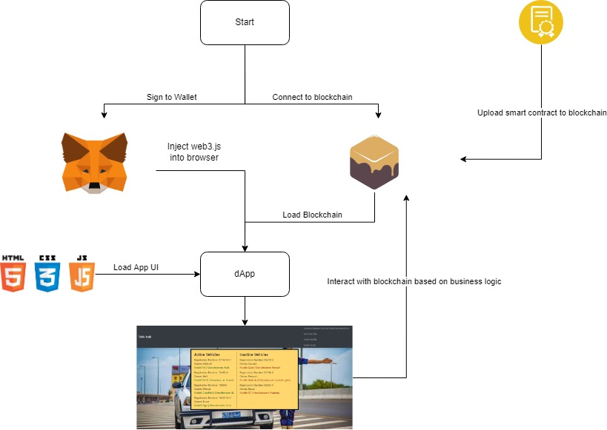

**Fig 1 : Control Flow Diagram**

Once the server is started, the dApp opens up on a new Chrome Browser window but it doesn’t show any data as the connection to the blockchain has not been authenticated. Once we sign into the wallet (Using MetaMask) and connect to the test network, the required web.js node module is injected and data is then read and displayed. Every interaction with the blockchain uses up gas and is paid with using the test account’s wallet that we setup on MetaMask.

1. The dApp on loading all connections will first call up the render() function. This function first sets the loading tag in the index.html page to active to indicate to the user that the webpage is loading. Simultaneously, it calls up the renderTasks() function which reads the blockchain block by block for data, which it then loads it into a template containing necessary html tags which is then injected into the original index.html page under the necessary list based on the activity status of the vehicle.
2. From here the user is given a range of choices as listed below:
   1. Add new Vehicle:

This redirects the user to the add_details.html page where the user is asked to fill out the form to register a vehicle. Once the user submits the form with valid data, the createTask() function is called which scrapes the form data and then checks the Smart Contract for the business logic on adding data. It then maps the data by taskCount and adds data to the struct which is then appended to a block on the blockchain. Once the data has been added, the user will be redirected to the index.html page where they can view the newly registered vehicle’s data which has added to the block

* 1. Search for a vehicle:

This redirects the user to the find_tasks.html where the user is asked to enter the name of the owner or the VIN number of the vehicle. Once the user inputs the required the data the SearchrenderTasks() function is called which iterates through the blockchain for an entry containing the given name or VIN number. If its present it returns the appropriate information

* 1. Admin portal:

This redirects them to the admin_login.html page where the user is presented with all of the data present on the blockchain and can choose from toggling the status of a vehicle from active to inactive and vice-versa. This is possible by changing the status of the data present in that particular block using the toggleCompleted() function. Any change to data creates a new block and only the most recent data is read

# CHAPTER 4

## RESULTS